Ramsay’s Forgotten Railway Line
By Alec Hamilton
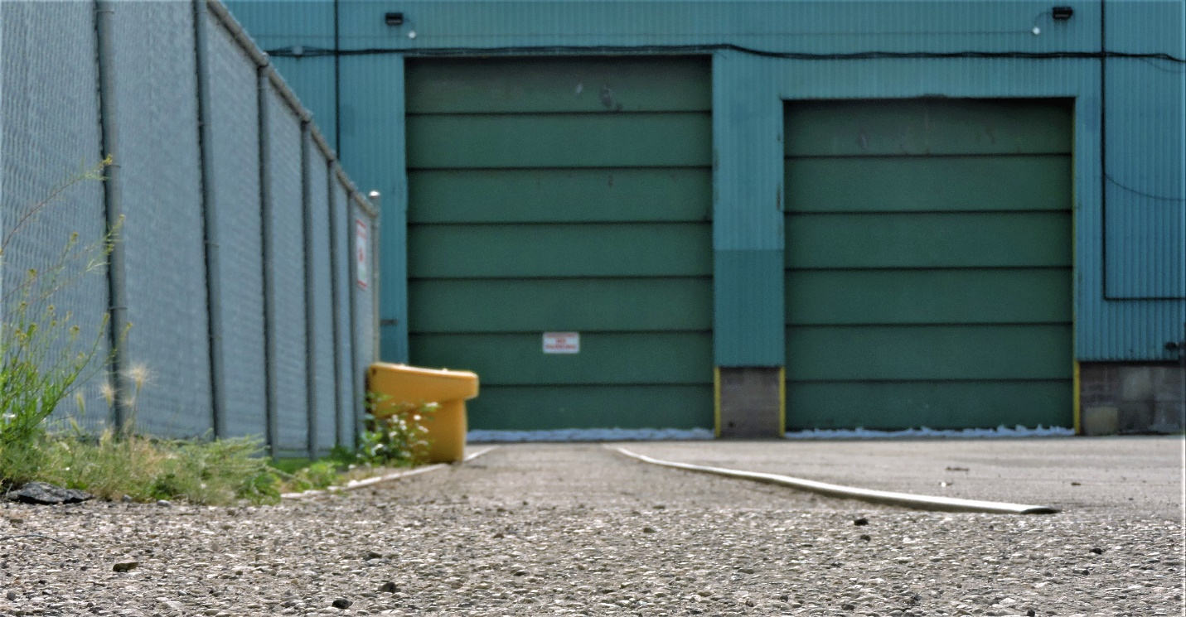
Remains of a spur track off the Canadian Northern main line in Calgary. This small portion of the track (which is still here) was probably laid in the early 1930’s or late 1920’s.
Ramsay is surrounded by railways. The CTrain borders Ramsay’s west side. The CPR surrounds Ramsay’s north and east sides. Hold on. There’s no railway track that borders the south side of Ramsay! Ramsay is not fully surrounded by track. In 2022, I’d be correct saying that. If I said that in 1981, I’d be dead wrong. Between 1981 to 1983, Ramsay was completely surrounded by railway track. I’m about to explain to you the history of a rail line you probably never knew was there. This track lasted in Ramsay for about 75 years, and for 60 of those years, it was one of the most important tracks in the city! All aboard!

In 1911, the Canadian Northern Railway extended their network into Calgary. Their line came into Calgary from Drumheller and entered the east side of the city. The Canadian Northern purchased the St. Mary’s Parish Hall to be their station in Calgary. That building is now the Alberta Ballet building off 18th Ave SE. They extended their track from the east into the Beltline, to reach the station – and the Ramsay area of the track can be seen in the map below: The track wove its way across the Bow River and what was to become Deerfoot Trail, then it went through the Highfield area. It branched into two tracks. The west track went over Blackfoot Trail. The east one crossed it at grade. The rest of the trackage can be seen in the below map:
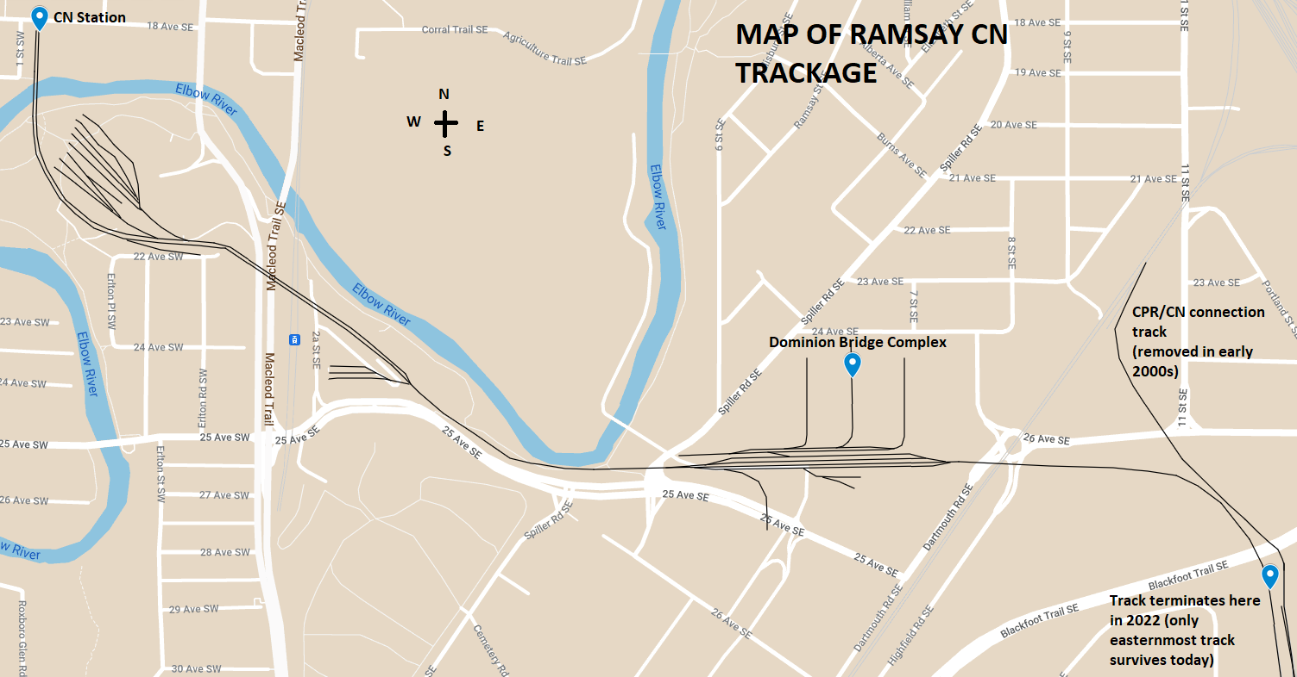
The track was one of Calgary’s most important railway lines. It started seeing mostly passenger trains. Then it saw more freight trains as industrial areas began appearing around the track. It continued like this until 1971, when the Canadian National (CN) (which had taken control of the Canadian Northern in 1919) deemed passenger service in Calgary unprofitable and closed the station. The track became 100% freight service and was shortened to the Dominion Bridge complex in the mid 1970’s. In the late 1980s, Dominion Bridge closed their plant in Calgary and the line was shortened to where it terminates today (circa 1990), just on the south side of Blackfoot Trail by the Crossroads Market. This once-important track now serves a handful of industries in Highfield. It probably sees about 2 trains a week, instead of …maybe 5-10 per day when it was going strong.
If you know what to look for, you can see where the line ran even in 2022. Start at Blackfoot Trail, behind the Crossroads Market. Can you see the concrete buttresses that held up a bridge over it? What about the warning signs with the CN logo? Now, look behind the Crossroads, and maybe you’ll see the levelled ground on the side of the hill with some derelict telegraph poles. Once you know there was a track here, it’s easy to point out all the clues telling you that this area once had an important railway line running through it. You can use satellite view (the most helpful railroad-line-sleuthing tool available).
Finally, behind the Dominion Bridge complex, there was a railyard. This area was called McKee, and there was a roundhouse there until ~1963. So, if you live on the south side of Ramsay, you’d like to know that there was a roundhouse a few blocks from you.
Yes. A real roundhouse and turntable in our little neighbourhood.

